**Fatima Jinnah Women University**

Department of Software Engineering

**LAB 8**

**Name:** Raifa Khalid

**Reg. no:** 2020-BSE-024

**Section:** A

**Semester:** Fourth

**Course:** Data Base (LAB)

**EXAMPLES:**

*Sub Query:*

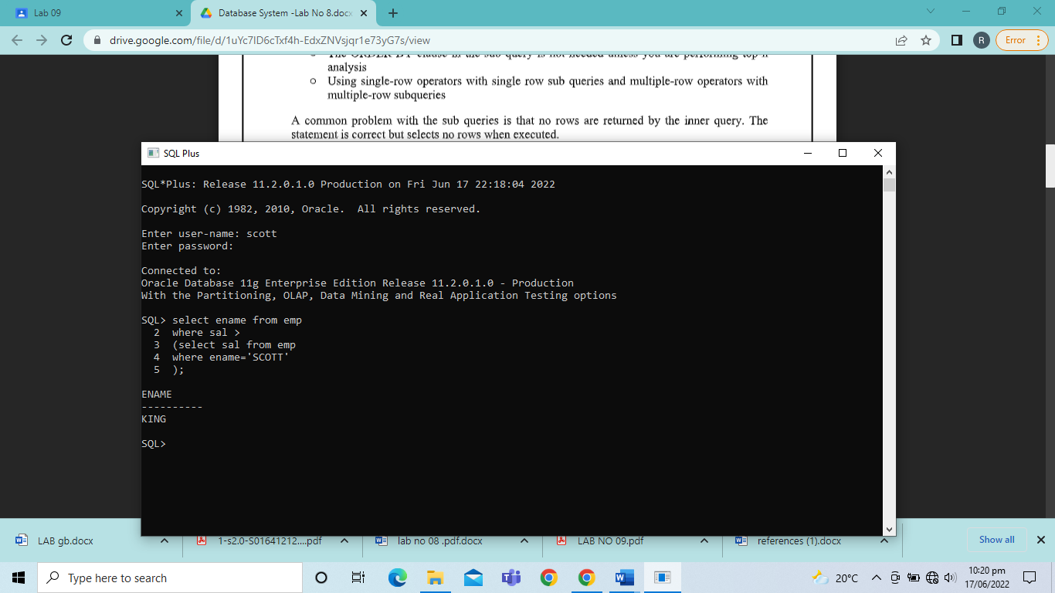

*Single-Row Sub Queries:*

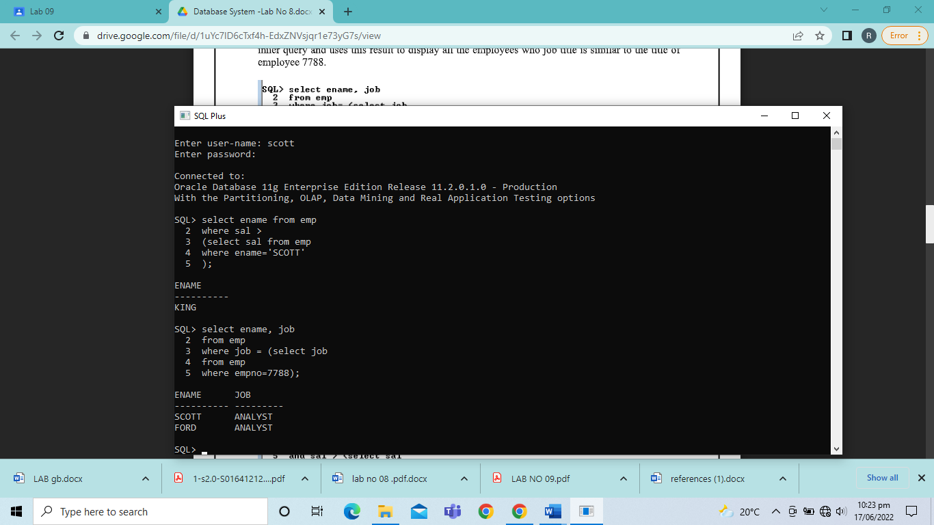

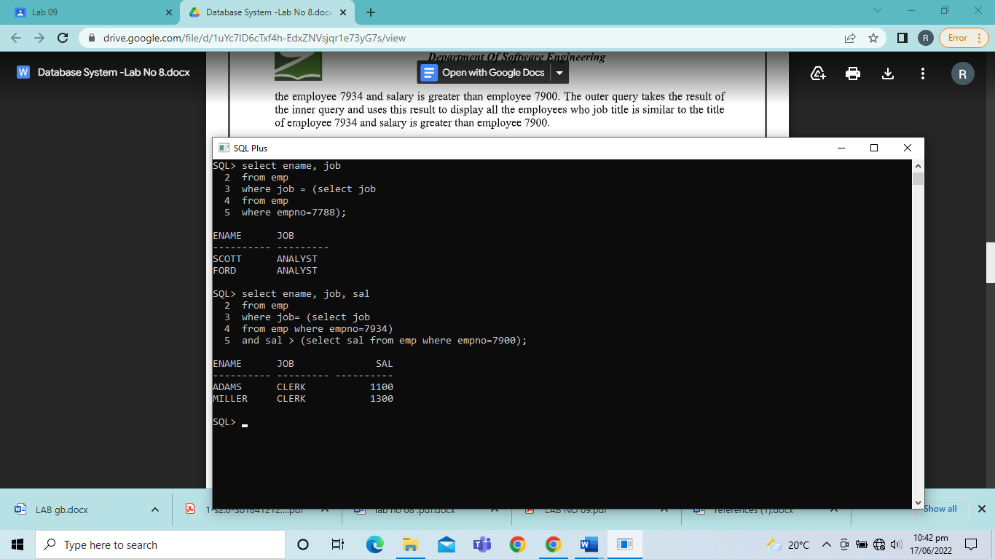

*Multiple-Row Sub Queries:*

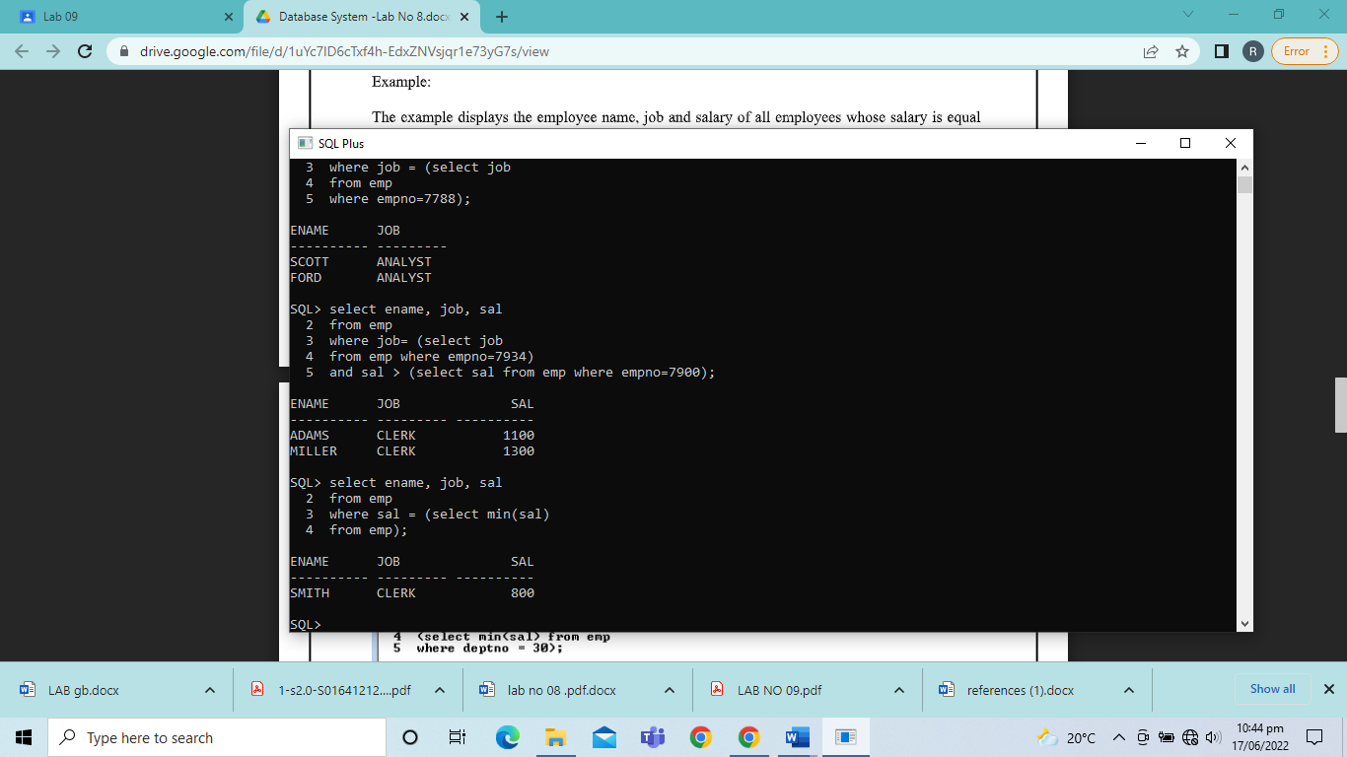

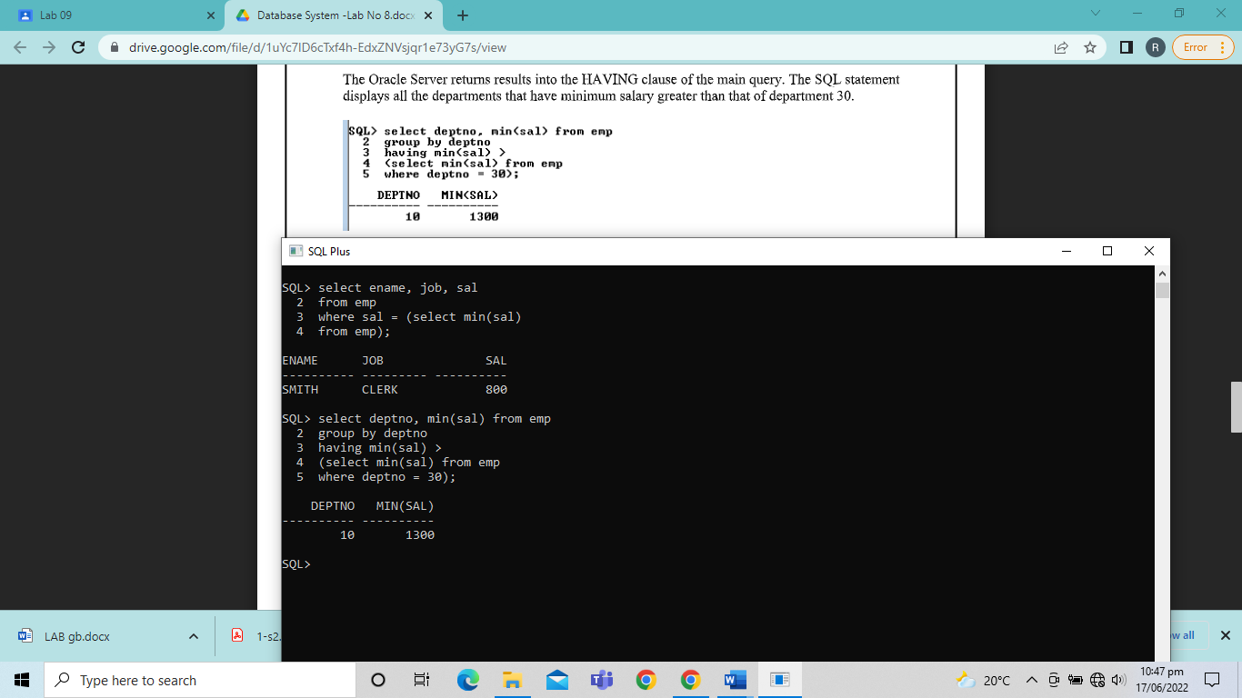

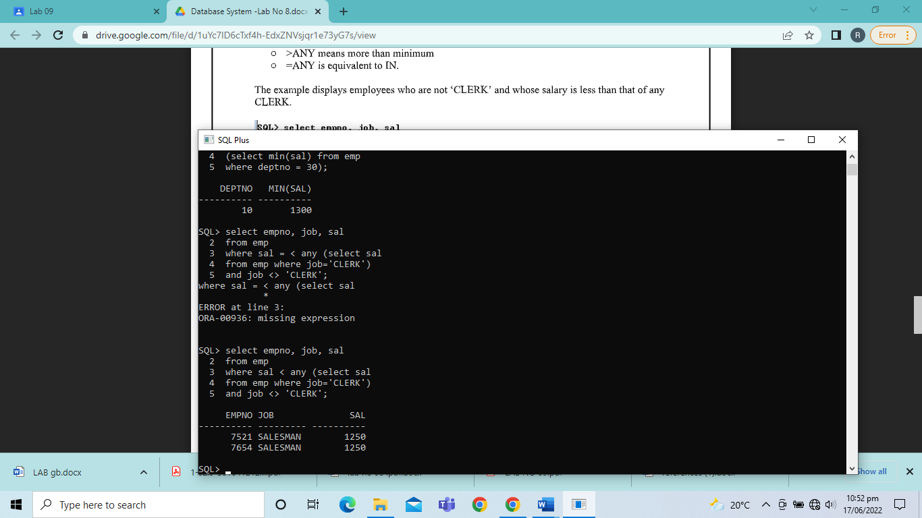

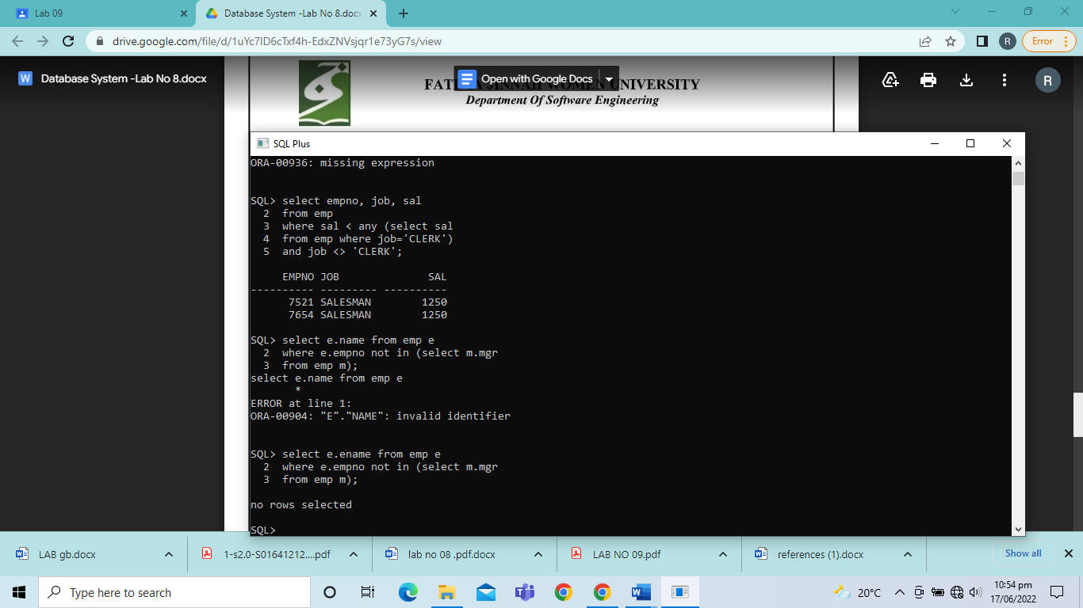

TASKS

1. Write a query to display the employee name and hiredate of any employee in the same department as SCOTT. Exclude SCOTT.

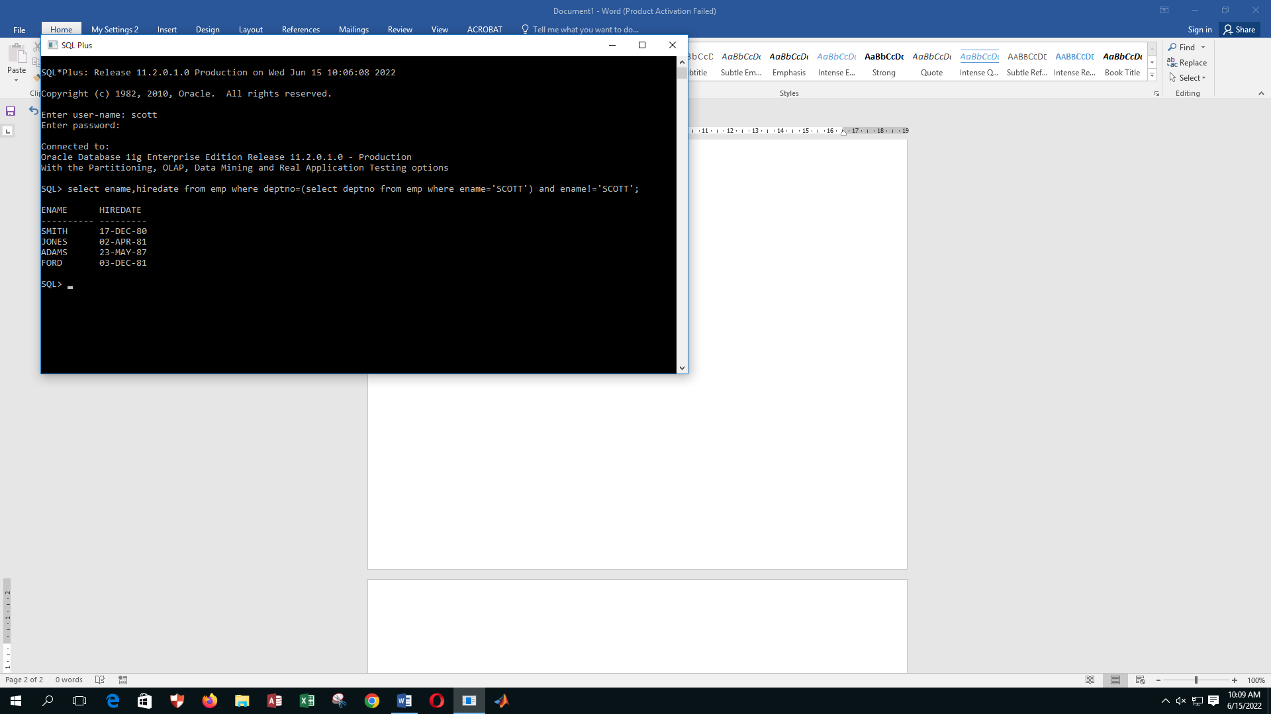

1. Create a query to display the employee number and name of all employees who earn more than average salary. Sort the results in ascending order of salary.

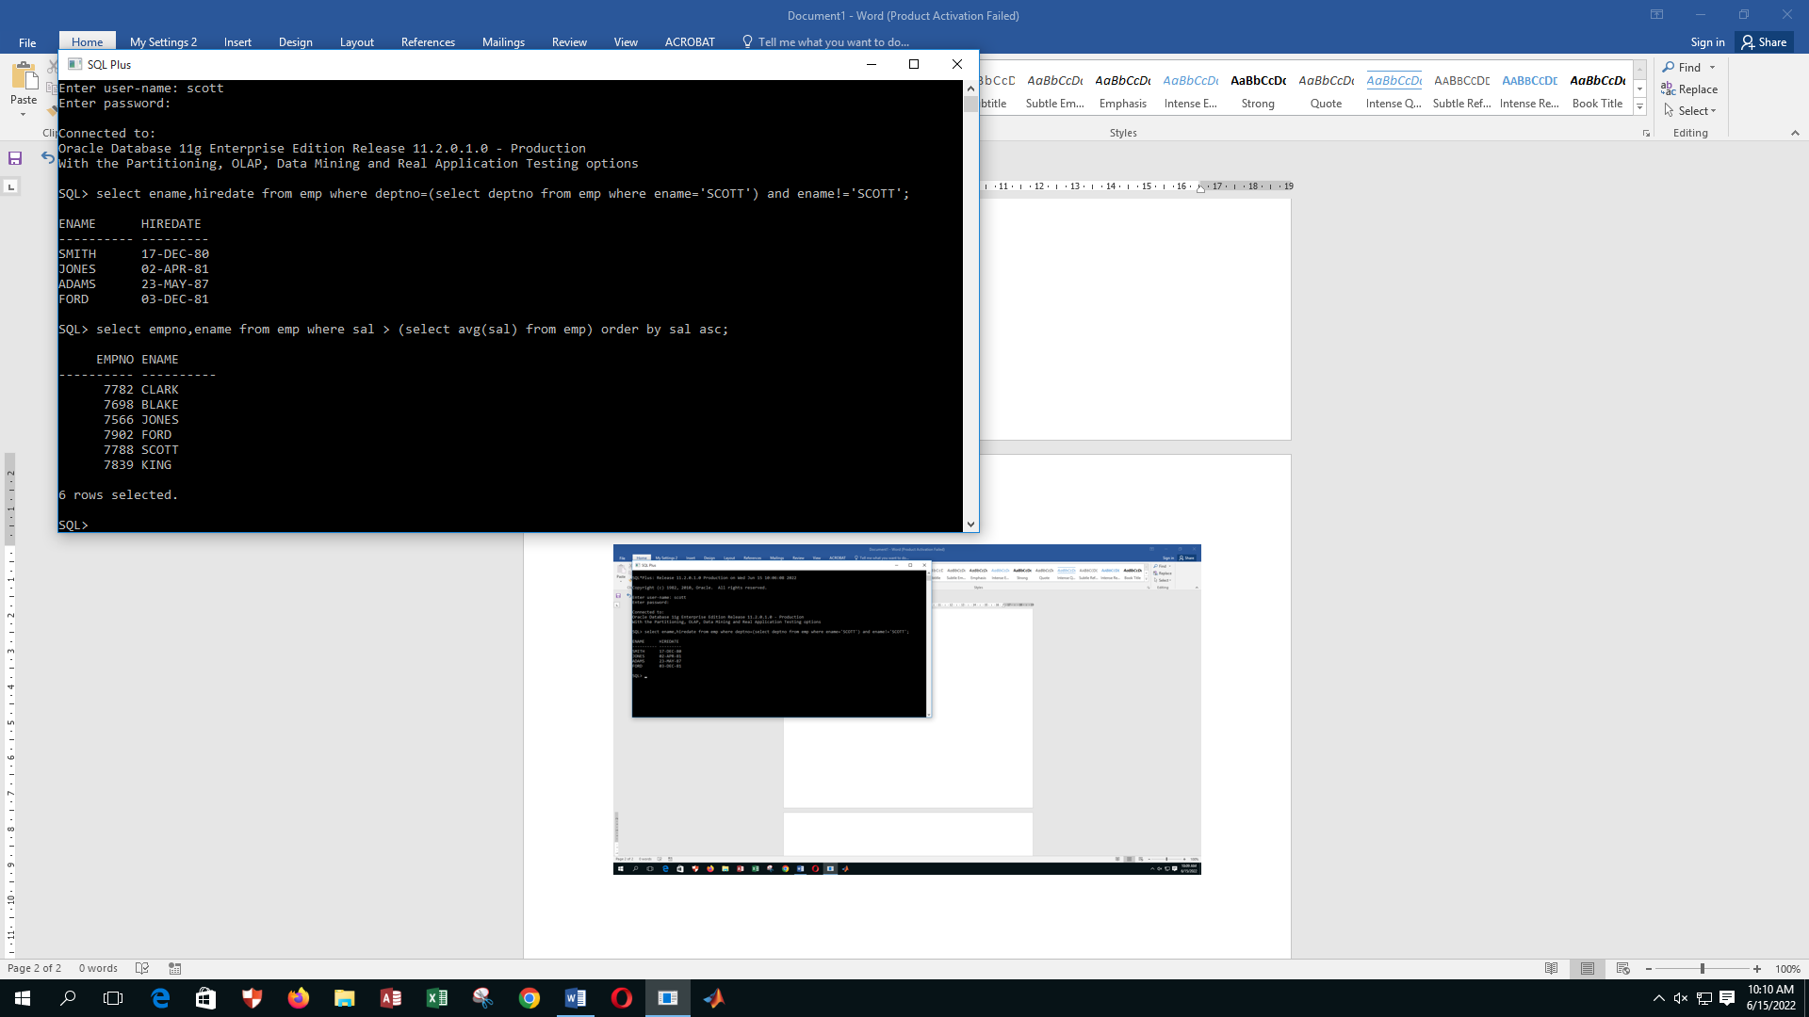

1. Write a query that displays the employee number and name of all employees who work in a department with any employee whose name start with “S”.

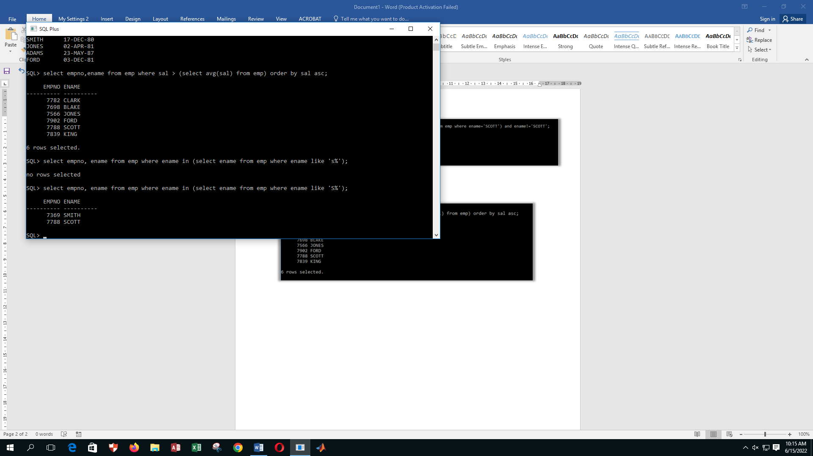

1. Display the employee name, department number, and job of all employees whose department location is CHICAGO.

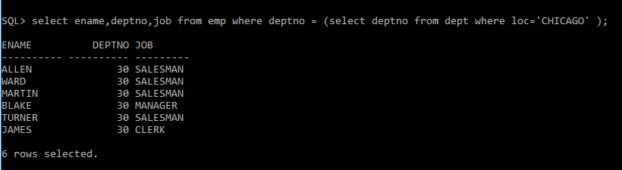

1. Display the employee name and salary of every employee who reports to King.

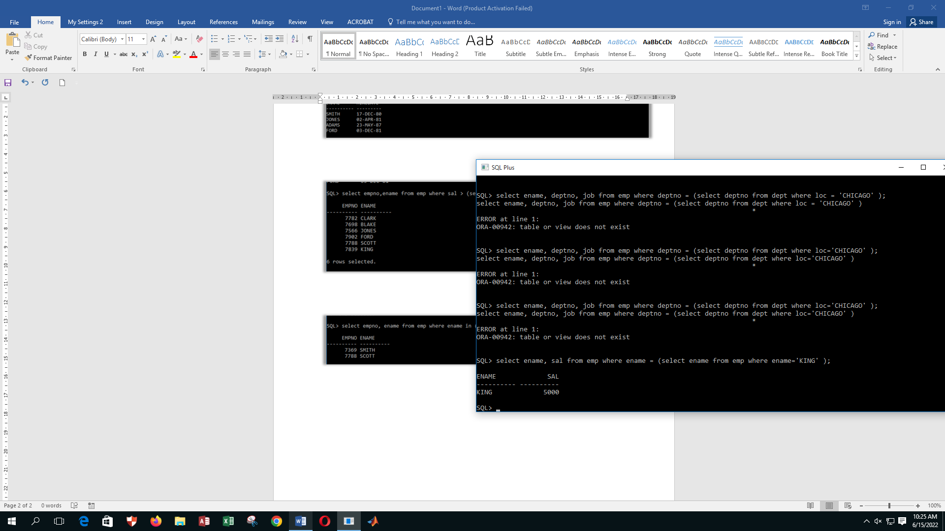

1. Display the department number, employee name and job for every employee in the OPERATION department.

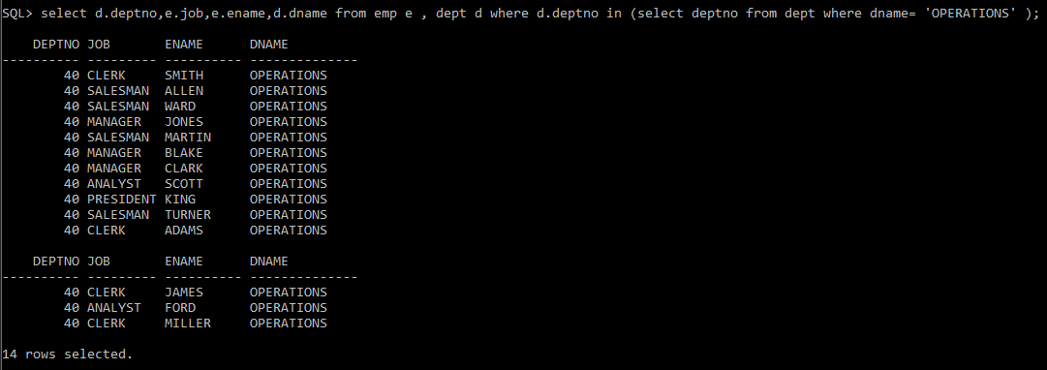

1. Write a query to display the employee number, employee name and salaries of all employees who earn more than average salary and who work in a department with any employee with “A” in their name.

